Task No 01: Create a table “Customer” and add the fields First Name, Last Name, City, Zip Code, in the Customers table and create a Query.
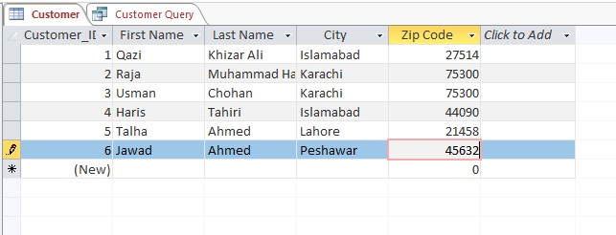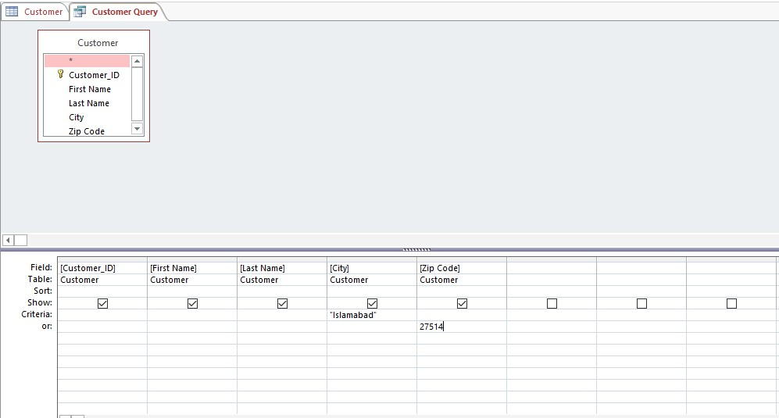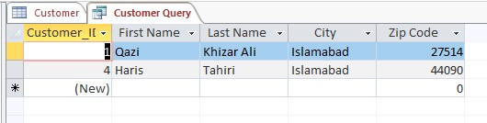

Task No 02: Create two tables namely tblCustomer, tblOrders. Insert three records into this table and find the given relationship among them and save the results.
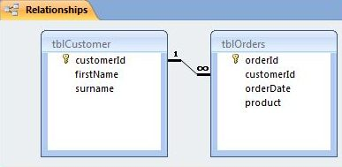
Solution:
